An integer construction of the proton to electron mass ratio in the Lattice Structure Manifold
Ben Đ Om
DCLXVI LC · Wisconsin Rapids Wisconsin USA · https://dclxvi.lc
29 September 2026 · Version 1 · Research preprint

Abstract
An integer mass construction within the Lattice Structure Manifold (LSM) gives the proton to electron mass ratio 25,412,353/13,840 = 1836.152673410404624…, differing from the 2022 CODATA central value by −8.494 parts per trillion. The residual is −0.4874 times the quoted standard uncertainty. The construction combines an 8T + 1O electron inventory with a selected 8T + 7O proton inventory, where T and O denote tetrahedral and octahedral interstitial cells. In an explicitly specified face-centered cubic lattice, the proton inventory is a minimum-cell, charge +e construction constrained to contain the complete interstitial first shell around one host. A retained neutral-node contribution of 73,360 face units gives an uncorrected ratio of 1836.2. Introducing K integer quanta per face and subtracting B proton binding quanta yields R(K,B) = (73,448K − B)/(40K). An exact integer-interval search establishes K = 346 and B = 655 as the first admissible pair when K is minimized against the published one-standard-uncertainty interval. This paper supplies the geometry, mass conventions, exhaustive arithmetic certificate, and reproducible code. The result is a retrospective compatibility construction. The zero parameter objective requires an independent physical rule selecting the node term, K, and B; that rule remains to be derived.
Keywords: Lattice Structure Manifold; proton electron mass ratio; integer mass accounting; FCC geometry; rational approximation

1 Scope and principal result
The dimensionless ratio mₚ/mₑ is a direct test of any proposed common account of proton and electron mass. LSM investigates whether particle properties can arise from interstitial structures in a close-packed substrate. The present paper isolates one concrete result from that program: an exact rational mass assignment that lies within the published CODATA uncertainty interval [1]. It states every numerical input needed to reproduce the comparison, without requiring access to a private spreadsheet.
Quantity | Value
CODATA 2022 ratio R₀ | 1836.152673426
Quoted standard uncertainty u | 0.000000032
LSM integer construction R* | 1836.152673410404624…
Signed difference R* − R₀ | −1.559537572 × 10⁻⁸
Relative difference | −8.493507075 × 10⁻¹²
Difference divided by u | −0.4873554913

The table compares with the published rounded central value and standard uncertainty. Additional digits in R* describe the exact rational number; they are not additional experimental precision. Agreement within u is the arithmetic acceptance criterion used here, and does not independently validate the proposed physical interpretation.

2 Lattice geometry and particle inventories
T denotes a tetrahedral interstice and O an octahedral interstice. Their flat reference polyhedra have four and eight triangular faces. The LSM charge convention used throughout this paper is qT = −e/6 and qO = +e/3. A host is taken to be neutral. Consequently, an inventory containing T tetrahedral cells and O octahedral cells has charge and raw face-incidence count
Q/e = (2O − T)/6, F = 4T + 8O. (1)
A face incidence belongs to a particular cell. A shared physical face contributes two incidences. If I pairs of cells share a triangular face, the number of exposed triangular openings is F − 2I. These two counts serve different purposes and must not be interchanged in the mass rule.
Use Cartesian coordinates in which host centers occupy integer triples with odd coordinate sum. Octahedral centers occupy integer triples with even coordinate sum, and tetrahedral centers occupy half-integer triples. The vertices of each reference cell are its nearest host centers. Two cells are face neighbors exactly when their vertex sets share three hosts. Multiplying all coordinates by √2 makes the radius of touching host spheres equal to one.
The electron inventory consists of an octahedron at (0,0,0) and eight tetrahedra at (±1/2, ±1/2, ±1/2). It has charge −e and Fₑ = 40. For the proton, choose the host h = (1,0,0). Its complete interstitial first shell consists of eight tetrahedra at h + (±1/2, ±1/2, ±1/2) and six octahedra at h ± eᵢ, where eᵢ are the three Cartesian unit vectors. Add the exterior octahedron at (2,1,1). This produces the selected 8T + 7O cluster with charge +e and Fₚ = 88.
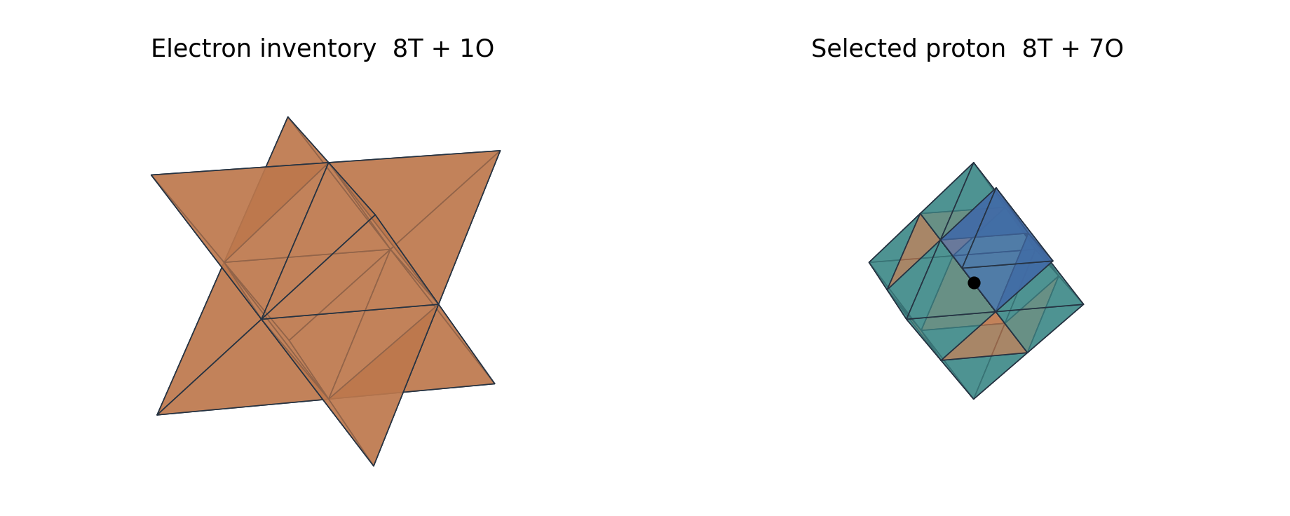
Figure 1. Flat reference-cell geometry for the electron inventory and selected proton inventory. Orange denotes T, teal denotes O, and blue marks the seventh proton O. The black point marks the enclosed host in the proton panel. Only external polyhedral faces are shown. These polyhedra encode incidence; they do not represent a derived deformation of the physical host or curved void walls.
The complete 8T + 6O shell contains 14 compulsory cells and carries charge +2e/3. Reaching +e requires an additional +e/3, supplied by one O. Thus 15 cells suffice and fewer cannot satisfy both conditions. This proves a constrained minimum over clusters containing that complete FCC shell. It does not prove a global minimum over all positively charged clusters. The exact audit gives I = 25 and F − 2I = 38 for the selected cluster. Its exterior O connects through one face, so physical resistance to detachment requires an energy law. The construction is FCC-specific; the shared T:O inventory ratio of FCC and HCP does not make their face adjacencies interchangeable [2].

3 Mass accounting and the remaining residual
The electron fixes the conversion from a face-incidence count to a conventional mass unit: one bare face unit is mₑ/40. This is a normalization, not an independent determination of mₑ. An equivalent weighted-cell convention uses W = T + 2O and F = 4W. Using the CODATA electron rest energy mₑc² = 0.51099895069 MeV gives a face energy of 12.77497376725 keV [1].
The proton assignment retains the LSM enclosed-node contribution N = 73,360 face units. This value equals 16 × 4,585 in the existing bookkeeping: 16 is the face count of the neutral 2T + 1O interstitial inventory, and 4,585 is the adopted enclosure factor. This identity explains the accounting; the factor and its transfer to the selected cage are physical assumptions in this construction. The geometric shell proof alone does not determine a host rest energy.
Component | T | O | Charge in e | Bare face units
Electron inventory | 8 | 1 | −1 | 40
Complete proton cage | 8 | 6 | +2/3 | 80
Exterior octahedron | 0 | 1 | +1/3 | 8
Selected proton shell | 8 | 7 | +1 | 88
Retained enclosed node | — | — | 0 | 73,360

With that node assignment, the uncorrected mass ratio is
Rbare = (N + Fₚ)/Fₑ = (73,360 + 88)/40 = 1836.2. (2)
Its excess over the CODATA value is 0.047326574, or +25.77485777 parts per million. In the electron-calibrated mass convention this corresponds to about 24.18383 keV/c², or 1.89306296 face units. A correction is therefore needed to reproduce the measured ratio at its stated precision.
There is a simple obstruction to achieving this by changing only additive whole-cell counts. In the charge +e sector, Eq. (1) implies T = 2O − 6, hence F = 16O − 24. Neutral T/O contributions add multiples of 16. Relative to the 40-face electron, this class of bare ratios lies on a grid with spacing 16/40 = 2/5. The observed value lies off that grid. Subdividing every face equally changes numerator and denominator by the same factor and leaves the ratio unchanged.
Introduce a positive integer K, the number of mass quanta per face, and a nonnegative integer B, a proton binding subtraction. Set the electron binding correction to zero as the reference. The dimensionless mass counts and their conversion are
Mₑ = 40K, Mₚ = 73,448K − B, μ* = mₑ/(40K). (3)
R(K,B) = Mₚ/Mₑ = 1836.2 − B/(40K). (4)
Here B is a candidate rest-energy correction expressed as an integer. Calling it binding does not establish its microscopic mechanism. Equation (4) is the explicitly defined model class searched below.

4 Exact integer search and minimality certificate
Let R₀ = 1836.152673426 and u = 0.000000032. The acceptance condition is |R(K,B) − R₀| ≤ u. Multiplying by the positive denominator 40K gives an equivalent closed interval for B:
K[73,448 − 40(R₀ + u)] ≤ B ≤ K[73,448 − 40(R₀ − u)]. (5)
For each K, let L(K) and H(K) be the lower and upper bounds in Eq. (5). An admissible integer exists exactly when ceil(L(K)) ≤ floor(H(K)). All decimal inputs can be stored as rational numbers, so this decision requires no floating-point tolerance. Testing K = 1 through 346 finds no admissible integer for K < 346. At K = 346 the interval is
654.99934128 ≤ B ≤ 655.00022704. (6)
It contains the single integer 655. Substitution gives
Mₑ = 13,840, Mₚ = 25,412,353,
R* = 25,412,353/13,840 = 1836.152673410404624…. (7)
Among all K < 346, the closest value occurs at K = 187, B = 354. Its residual is +11.58723262u, outside the acceptance interval. This supplies a useful independent summary of the exhaustive certificate. Figure 2 shows every tested K; the accompanying CSV preserves all 346 rows.
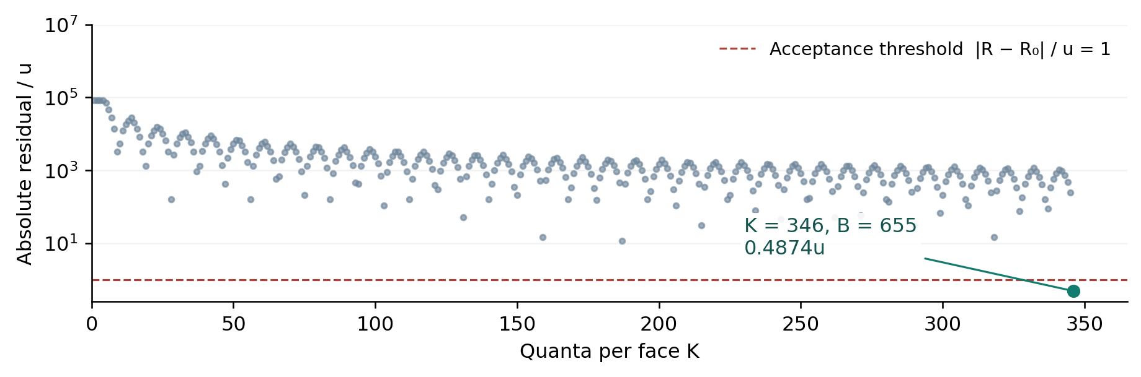
Figure 2. Absolute residual in units of the quoted CODATA standard uncertainty, using the nearest integer B at each K. The ordinate is logarithmic. The horizontal line marks the acceptance threshold; the first accepted point is K = 346. The algorithm tests exact interval bounds; floating-point values are used only to draw this figure.
The associated quantum is μ* ≈ 36.92188950 eV/c². The binding subtraction is Bμ*c² ≈ 24.18383762 keV. These are electron-calibrated consequences of the selected pair. Their difference from the uncorrected excess follows from the small signed residual in Section 1, rather than from a separately calculated binding energy.

5 Interpretation and testable scope
The construction establishes two results within its stated assumptions. First, the FCC first-shell constraint and charge rule select a 15-cell minimum inventory, realized by the explicit 8T + 7O coordinates. Second, the integer mass model with the retained node term admits a smallest-K solution within the chosen CODATA interval. The near agreement is numerically reproducible and can be checked independently with exact arithmetic.
The discovery procedure used observations to narrow the search. In particular, Eq. (5) uses the measured proton to electron ratio and its uncertainty to select K and B. Therefore the residual of −0.4874u is a descriptive comparison after selection, not a significance statistic for an independent prediction. The construction does not assign a probability that LSM is correct, and there is no justified random-search null model from which to infer such a probability here. Minimizing K is a stated arithmetic selection rule; it is not yet a consequence of lattice dynamics.
The zero parameter objective is a common physical rule that fixes the allowed states and their energies. For the present ratio that requires a derivation of the enclosure contribution, the face subdivision K, and the subtraction B, with the same rule applying to the electron. A fixed integer is still an empirical choice when its value was selected using the target measurement. Freezing the selected values makes later tests well specified, but does not retrospectively turn the selection measurement into a withheld test.
Mass matching alone also cannot uniquely determine the baseline node assignment when B is unrestricted. If the total baseline C = N + Fₚ is changed to C + d for integer d, replacing B by B + dK leaves (CK − B)/(40K) unchanged whenever the revised counts are allowed. Independent constraints on the host contribution and permitted binding counts are needed to break this degeneracy. A physical model must likewise distinguish arrangements with identical T and O counts; their face-incidence masses alone are identical.

5.1 Stability and dynamics
The exterior O has a single face connection to the complete cage. Geometry establishes that connection but does not determine its binding strength or the stability of the cluster against detachment and rearrangement. An energy operator, its admissible states, and allowed transformations must supply those answers. A dynamic interpretation must additionally connect the proposed substrate to particle spin, propagation, and interaction observables. None of these quantities is calculated by the integer search.

5.2 Universality of the mass quantum
The value μ* ≈ 36.9 eV/c² is too large to serve as a universal positive integer rest-mass quantum for ordinary light neutrinos. For comparison, the 2025 KATRIN result bounds the effective electron-neutrino mass below 0.45 eV/c² at 90 percent confidence [3]. The bare neutral inventory 2T + 1O would carry 16 face units, about 204.4 keV/c², under the same additive rule. A universal model would therefore need further structure, such as a different relation between inventory and net rest energy. The present K is a proton-electron compatibility scale, and is not established as a fundamental scale for the full spectrum.

5.3 A prospective test
A decisive next result would derive N, K, and B from a specified local law without using R₀ as its selection criterion, then evaluate additional observables withheld from that law's calibration. Publishing the law, prediction, and acceptance rule before comparison would distinguish a successful prospective test from retrospective selection. The fixed value in Eq. (7) can also be compared with future independent mass-ratio measurements; changing the integers after such a comparison would define a new model version.

6 Reproducibility
The accompanying package contains reproduce.py, geometry.json, results.json, search.csv, the figure-generation script, and the manuscript source. The arithmetic and incidence audit requires only the Python 3.9 or later standard library. From the package directory, run python3 reproduce.py. The script uses fractions.Fraction for interval decisions and decimal.Decimal for displayed values. It writes the exact ratio, residuals, interval endpoints, full search ledger, and lattice coordinates.
The geometry file uses doubled Cartesian coordinates, so all vertex and center coordinates are integers. Dividing them by two recovers Section 2. Face adjacency is checked by exact set intersection, without a mesh tolerance. The script verifies the electron and proton inventories, charges, face incidences, shared and exposed face counts, connectedness, and the proton's six signed-permutation symmetries about its enclosed host. It also verifies that removing the exterior-O connection disconnects the proton graph.
The complete search can be expressed by the following pseudocode. The bounds and rounding operations are evaluated as rational arithmetic.
for K = 1, 2, 3, ...:
L = K * (73448 - 40 * (R0 + u))
H = K * (73448 - 40 * (R0 - u))
if ceil(L) <= floor(H):
return K, integers from ceil(L) to floor(H)
# First result: K = 346, B = 655
No new particle measurement or fusion experiment is reported. The computations validate the stated geometry and arithmetic. The figure-generation script requires Matplotlib and NumPy; those packages are unnecessary for reproducing the numerical certificate.

7 Conclusion
The selected LSM construction gives mₚ/mₑ = 25,412,353/13,840, a relative difference of −8.494 parts per trillion from the CODATA 2022 central value. The exact search proves that K = 346 is the smallest positive face subdivision meeting the specified one-standard-uncertainty criterion in the model Mₑ = 40K and Mₚ = 73,448K − B. The constrained FCC geometry supplies an explicit 8T + 7O proton inventory; the matching mass subtraction is selected from observation. Together these results define a compact, reproducible target for the next stage of LSM: an independent physical derivation of the same counts and further tests under a common rule.

Data and code availability
The manuscript and reproduction package are available at https://dclxvi.lc/lsm-mass-ratio-paper.html. The experimental comparison uses the public NIST CODATA table [1]. The underlying LSM research record is publicly available at https://dclxvi.lc/publication.html [2].

References
[1] National Institute of Standards and Technology. Fundamental Physical Constants Complete Listing. 2022 CODATA adjustment. Entries for proton-electron mass ratio and electron mass energy equivalent in MeV. https://physics.nist.gov/cuu/Constants/Table/allascii.txt. Accessed 29 September 2026.
[2] Om, Ben Đ. Lattice Structure Manifold. Public research exposition and integer mass construction. DCLXVI LC. https://dclxvi.lc/publication.html. Source state 4ed0b8823feba5d6970b5efd7cf67a6a0918c9d4, examined 29 September 2026. The present paper restates the necessary assumptions, coordinates, and equations.
[3] KATRIN Collaboration. Direct neutrino-mass measurement based on 259 days of KATRIN data. Science (2025). Official collaboration results page: https://www.katrin.kit.edu/1271.php. Published 10 April 2025. Accessed 29 September 2026.

